// MOMENTUM WORLDWIDE

Technology Requirements Document:
Unified Experience Data

Goal
To implement a unified data solution that integrates data from disparate sources into a single view, providing accurate answers to critical questions.
A standardized and repeatable process is required for scheduling and recording event dates and details within a master activation calendar, applicable to all clients.

The implementation of this technology solution will allow for a streamlined process of data aggregation and provide a centralized location for all connected data.

With this technology, Momentum and Its clients can make informed decisions based on accurate and complete data, ultimately leading to better business outcomes.

Objectives
- Establish a unified data model
- Generate a consistent Global Unique Identifier (GUID) for each activation
- Create a method to capture all activations. Identifying owners, types, dates, and locations
- Generate a master campaign Identifier (Parent ID) and an event date Identifier (Event ID)
- Create the ability to integrate post-event metrics from other systems
- Create the ability to integrate with event management systems used by Momentum
This project aims to create the Unified Experience Tracker (UET)

The UET will enable the Momentum activation calendar, identify activations owners, types, dates, and locations, and join meaningful post-event metrics. The Unified Experience Tracker will generate a consistent Global Unique Identifier (GUID) for each activation, Improving the current data environment to ensure scale. The data hub with be able to connect with multiple event management systems used by Momentum.

Deliverables
- Unified Experience Tracker (UET) and Input Procedure
A front-end Input application and organization-wide process/system for collecting Activation Details and information: Activation Name, Activation Date, Activation Client, and Activation Location.
- Unified Experience Datawarehouse & APIs
One location for all IDs and data generated from UET.
Data models and processes (ETL) to manage changes/updates within UET
Centralized data infrastructure that can be enriched with additional IDs and data from other 3rd party systems.
Bidirectional APIs to communicate with 3rd party services to send and receive data.
- Organization-wide BI/Analytics Dashboard (Experiential Intelligence Dashboard)
An accessible and interactive web-hosted dashboard visualizing data from the data warehouse via KPIs and other metrics for Momentum and its clients
Scope
The scope of the project includes five aspects.
- Conducting a process & data discovery
- Developing an application that can gather and unify data, allowing users to edit all data, generating a Master campaign Identifier (Parent ID) and Master event Identifier (Event ID), and storing all data within an Azure SQL database.
- API: Send event Information to any required system to create an event and receive back IDs so that bidirectional updates can be performed from either system.
- Data governance: create a method to ensure data quality and completeness. This will also Include client MSA conditions, IPG data compliance and archive processes.
- Training: All teams on how to enter events into the new application
Scope Phase One
For the purpose of this scope, only the first two deliverables are considered.
- Unified Experience Tracker: Front-end app
- Database: That holds all ID, and base Information and can be enriched with additional IDs and transactional data from other 3rd party systems
- APIs that connect bidirectionally with 3rd Party systems.

Target Users:
The application's target users are all business leaders and project managers who manage activations.

Feature | Benefit | Pain Solved
Unified Experience Tracker (UET) | Centralized management of activation data | Scattered and disorganized data across multiple systems
Master Program ID & Event ID | Unique identifiers for each campaign and event | Difficulty in tracking and managing events
API Integration | Seamless communication with field management systems | Manual data transfer and synchronization
Unified Database | Consolidated data storage | Redundancy and inconsistency in data storage
Calendar View | Easy visualization of scheduled events | Inefficient event planning and tracking
Client Power BI Dashboards | Customizable data visualization for clients | Limited client access to data and insights
Synchronization between systems | Real-time data updates across UET and field management systems | Inconsistent data between systems
Permissions and access control | Secure access to data based on client-defined permissions | Unauthorized access to sensitive data
Input and update data in both systems | Flexibility in managing activation and event wrap data | Inflexible data management process

Deliverables
The following deliverables are expected at the end of the project:

- Unified Experience Tracker
- Database to hold data captured by Activations app
- Test results and deployment documentation.
- Training material and sessions for the Momentum data team.
Requirements
The requirements for the application include master data and transactional data.
- Master Data
  - Client Name
  - Event Types
  - Status – Planned, Confirmed, Cancelled
  - Business Leadership – First & Last
  - Business Leadership – Email
  - Project Leader – First & Last
  - Project Leader – Email
- Transactional Data
  - Master Program Name
  - Master Program ID unique to each event]
  - Master Event Name
  - Event Date [Event ID] unique to each event day
  - Event Time, Start Time - End Time
  - Event Location, Full Address, Name of Venue (geo lookup?)
  - Last Update [Date]
- Last Update [Person]
- Recap Approval [Approved, Rejected]
- Functionality
- Date of event
- User may enter a date range or single dates.
- Each day of the event must be a unique row within the table.

- Master Event Name
  - All variables Read / Write / Edit
  - Single edit will update all occurrences related to the [Parent ID]

- API
  - Create Event API: This API will be responsible for creating new events in the field management systems when a user creates an event in the UET. It should accept the required event information, such as Parent ID (Master campaign Identifier), Event ID (Master event Identifier), event date(s), and other relevant details.
  - Update Event API: This API will handle updating existing events in the field management systems when a user updates an event in the UET. It should accept the updated event information and the unique identifiers (Parent ID and Event ID) to locate the event to be updated.
  - Close Event API: This API will manage closing or to cancel events in the field management systems when a user cancels an event in the UET. It should accept the unique identifiers (Parent ID and Event ID) to locate the event to be closed.
  - Event Wrap Data API: This API will send updated event wrap data from the field management systems back to the UET. It should accept the event wrap data and the unique identifiers (Parent ID and Event ID) to update the corresponding event in the UET.
  - Get Events API: This API will retrieve event information from the unified database to be displayed in the UET application and the Client Power BI Dashboards. It should support filtering, pagination, and sorting options for efficient data retrieval.
  - Vendor responsible for rate limiting, pagination, authentication, testing, and monitoring of APIs.

- Database
  - Database Type: A relational database management system (RDBMS) such as PostgreSQL, MySQL, or SQL Server would be suitable for the UET system since it requires structured data storage and complex relationships between data entities.
  - Database Schema: The schema should include tables for storing the following entities:
    - Clients
    - Event Types
    - Event Statuses
    - Users (Business Leadership, Project Leaders)
    - Events (Master Program, Master Event, Event Date, etc.)
    - Field Management Systems
    - Field System Project IDs
  - The schema should also define fields, data types, primary and foreign keys, and constraints for each table.
  - Data Model: The data model should represent the relationships between entities, such as:
    - One-to-many relationships between clients and events, users and events, event types and events, and event statuses and events.
    - Many-to-many relationships between events, field management systems, and events and Power BI Dashboard Permissions.
    - Indexing and Optimization: Indexes should be created on commonly searched and filtered fields, such as Event ID, Master Program ID, Client Name, Event Date, and Event Status. Optimization techniques, such as query caching or denormalization, could be used to improve performance where necessary.
  - Data Security and Compliance: The database should enforce data security measures, such as:
    - Data encryption at rest and in transit.
    - Access control mechanisms to restrict unauthorized access to sensitive data.
    - Compliance with relevant data protection regulations, such as GDPR, CCPA, or HIPAA, depending on the nature of the data and the jurisdictions involved.
- Systems
  - Ideally, we would like to utilise Power apps that will allow users to create and edit the events.

- User Process Flow:
- End user logs into the UET application.
- User enters the name and date of the activation.
- User fills in the required master data and transactional data fields.
- User can view Calendar View to see all events scheduled.
- User presses the "Create Field Management Project" button.
- The system creates the campaign and events, generates the Master Program ID and Event ID, and stores the data in the unified database.
- UET sends the event ID and event date(s) to the field management systems via an API POST request.
- Field managers can view the information and enter event wrap data in their respective field systems.
- The field systems push updates (such as name, date, etc.) back to the UET via an API.
- User can update data in either the UET or field management systems and the changes are synchronized across both platforms.
- Data Flow:
- End user inputs data into the UET application, including master data and transactional data.
- UET stores the input data in the unified database.
- UET sends an API POST request to the field management systems, containing the Parent ID - Master campaign Identifier and Event ID - Master event Identifier for each day of the event
- Field management systems receive the event information and create project.
- Field management systems sends a response to UET with field system project ID
- Field managers can view projects and enter event wrap data.
- Field managers input event wrap data into the field management systems.
- Field management systems send updated event data back to the UET via an API.
- The UET application receives the updated data and synchronizes it with the existing data in the unified database.
- The unified database stores the updated data and makes it available to the UET application and connected client Power BI dashboards.
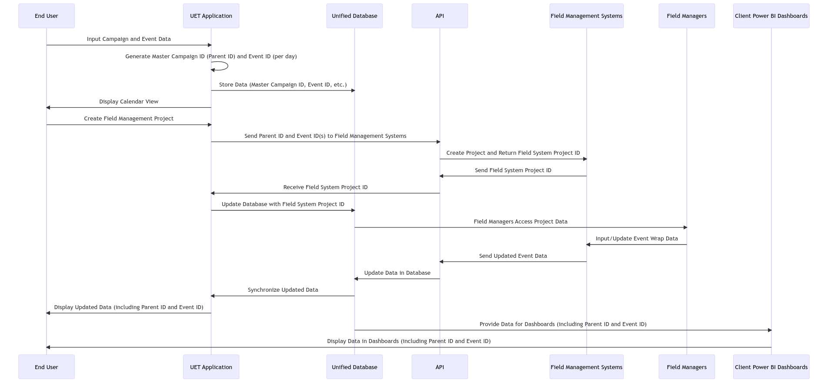
- Client Power BI dashboards display the data, with permissions set by the client, allowing authorized users to view and analyze the information.

DOCUMENT REVISION HISTORY

Author | Revision Date | Implementation Date | Reviewer | Comments

